AdvancedList for NGUI Tutorial(eng).

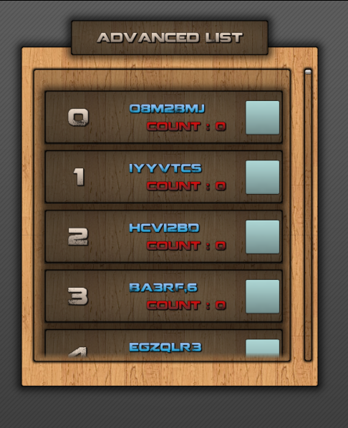

[**Demo**](http://unitydev.cafe24.com/02_asset/00_advList/)

**1. PackageImport**

**import NGUI ver 3.6.8(or higher),**

**and AdvanceList package.**

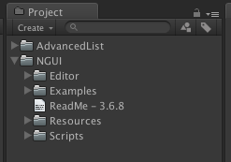

**2. Menu bar ->NGUI->Create->2D UI  Select, create a "UI Root".**

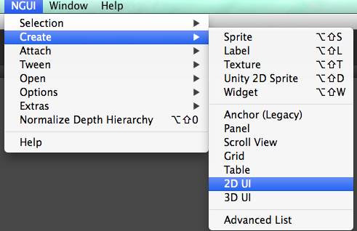

**3. Menu bar ->NGUI->Create->AdvancedList  Select,  
 create a "AdvanceList".**

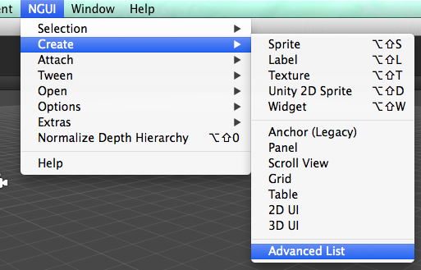

**4. "myList.cs" in the Examples folder, add "UIRoot".  
and, "advancedList / ScrollViewContent" drag and drop at Scroll Content.**

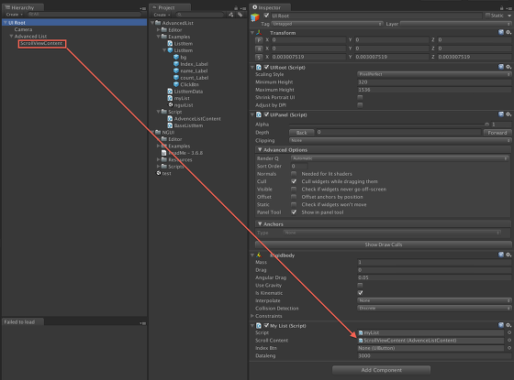

**5. select "advancedList / ScrollViewContent",   
Drag and drop "Examples/ListItem" prefab in Item .**

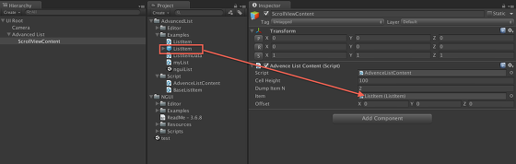

**6. Check the list by Run the play button.**

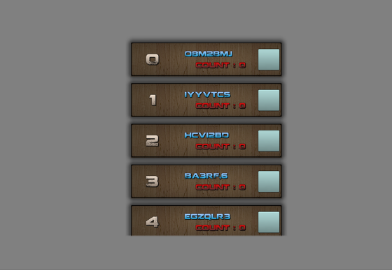

**Thanks.**

**contact us :** [**jincode.kr@gmail.com**](mailto:jincode.kr@gmail.com)

http://jincode.tistory.com/